

Your Future Won't Wait.

CLAUDE DESKTOP
Quick Start Guide
From Zero to Productive in 30 Minutes
The philosophy: you do the minimum setup.
Then Claude does the rest.

Prepared by Chuck Poole
Principal Consultant, White Rabbit Advisory Group
561-373-2547 | chuck@whiterabbitadvisorygroup.com
whiterabbitadvisorygroup.com
April 2026 | Version 7.5

How This Guide Works
IMPORTANT: STUCK? PASTE THIS ENTIRE DOCUMENT INTO CLAUDE DESKTOP

If you run into any problems at all, open Claude Desktop and paste this entire document into the chat with the message: "Walk me through this setup step by step." Claude will read the guide, understand every step, and walk you through the entire process interactively. You do not need to figure anything out alone.
Most AI setup guides give you 20 steps of manual configuration. This one gives you 7 steps of clicking buttons, then hands the rest to Claude itself.
- Part 1: Install the app, install Python (required for one extension), install uv, add extensions from the built-in directory, install Claude for Chrome, and enable Computer Use. No code, no config files. About 15 minutes (includes a reboot).
- Part 2: Paste a single prompt into Claude and watch it set itself up and verify everything works. About 5 minutes.
- Part 3: Try a series of demo prompts that show off what Claude Desktop can actually do. About 15 minutes.

By the end, you will have a fully configured Claude Desktop with the ability to control your computer, read and write files, search the web, and automate real work.

What Is Claude Desktop?
You may already be using Claude through your web browser at claude.ai. That works great for basic conversations, but it is limited to text chat.
Claude Desktop is a free app you install on your computer (like Word or Chrome). Once installed, Claude can do much more than just chat. With the right extensions, Claude can:
- Read and organize your files
- Run commands and check your system health
- Create Word documents, spreadsheets, and presentations
- Build interactive apps and data visualizations
- Search the web for current information
- Automate tasks on your computer

Think of it as upgrading Claude from a chatbot to a hands-on assistant.

Before You Start
☐ | Requirement | Details
 | Claude Pro Plan | $20/month at claude.ai/upgrade. Required for Projects, Artifacts, MCP servers, Opus model, and extended thinking.
 | Claude Desktop App | Download from claude.ai/download. Sign in with the same account.
 | Python | Required by the Windows-MCP extension. Step 2 walks you through installing it.
 | uv | Required by many MCP extensions. Step 3 walks you through installing it.
 | Windows 10/11 or Mac | This guide uses Windows examples. Mac steps are nearly identical.
 | 35 minutes | Includes a reboot after installing Python.

Why the Pro Plan Is Required
The free tier only gives you basic chat. The Pro plan ($20/month) unlocks everything that makes Claude Desktop worth using:
- Projects with custom instructions and document uploads
- Artifacts -- interactive apps, charts, downloadable Word/Excel/PowerPoint files
- MCP server connections (the power tools in this guide)
- Access to Claude Opus 4.7, the most powerful model
- Extended thinking, voice mode, and much more

IMPORTANT: Without the Pro plan, most of what this guide covers will not work. Subscribe at claude.ai/upgrade before continuing.

PART 1: SETUP
7 Steps, 15 Minutes, No Code Required

Step 1: Install Claude Desktop and Switch to Opus
- Go to claude.ai/download in your browser
- Click the Windows download button (or Mac if applicable)
- Run the installer and follow the prompts
- Launch Claude Desktop and sign in with your Pro account
- Type "Hello!" and verify Claude responds
- Switch to the best model: click the model name shown below the input bar on the right side (it may say "Sonnet"). Select Claude Opus 4.7 from the list. You do not need to start a new chat.
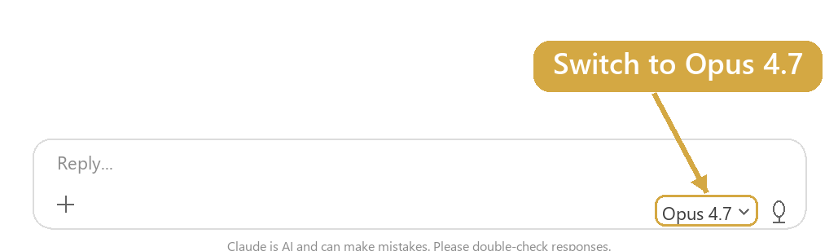
Click the model name to switch to Opus 4.7

Step 2: Install Python
The Windows-MCP extension requires Python to be installed on your computer. This is a quick, one-time install.
- Go to python.org/downloads in your browser
- Click the large "Download Python" button at the top of the page
- Run the downloaded installer

IMPORTANT: On the very first screen of the installer, check the box at the bottom that says "Add python.exe to PATH." This is critical. Without it, the extension will not work.

- Click "Install Now" and wait for it to finish
- Restart your computer. Python needs a reboot to take effect. After restarting, relaunch Claude Desktop and continue with Step 3.

Step 3: Install uv
uv is a fast Python package manager from Astral. Many MCP extensions and Python-based tools use it to manage dependencies. Like Python, this is a quick, one-time install.
- Press the Windows key, type PowerShell, and open the Windows PowerShell app
- Copy the command in the box below and paste it into PowerShell, then press Enter

powershell -ExecutionPolicy ByPass -c "irm https://astral.sh/uv/install.ps1 | iex"

- Wait for the installer to finish. You will see a message that says the installation is complete.
- Close and reopen PowerShell. This refreshes the PATH so the uv command becomes available. Then continue with Step 4.

Step 4: Install Extensions
Claude Desktop has a built-in extensions directory -- like an app store for AI tools. No coding, no config files, no terminal commands. Just click and install.
- Click on your name or profile picture in the bottom-left corner of Claude Desktop
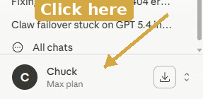
Your name and plan appear in the bottom-left corner
- Select "Settings" from the menu
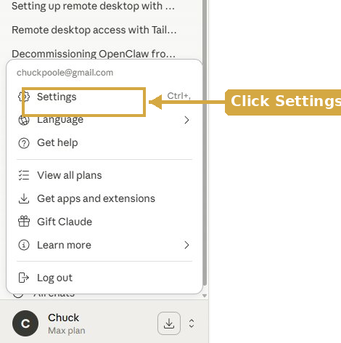
Click Settings from the popup menu
- Scroll down on the left side to the "Desktop app" section. Click "Extensions" (not the "General" above it -- that is for account settings)
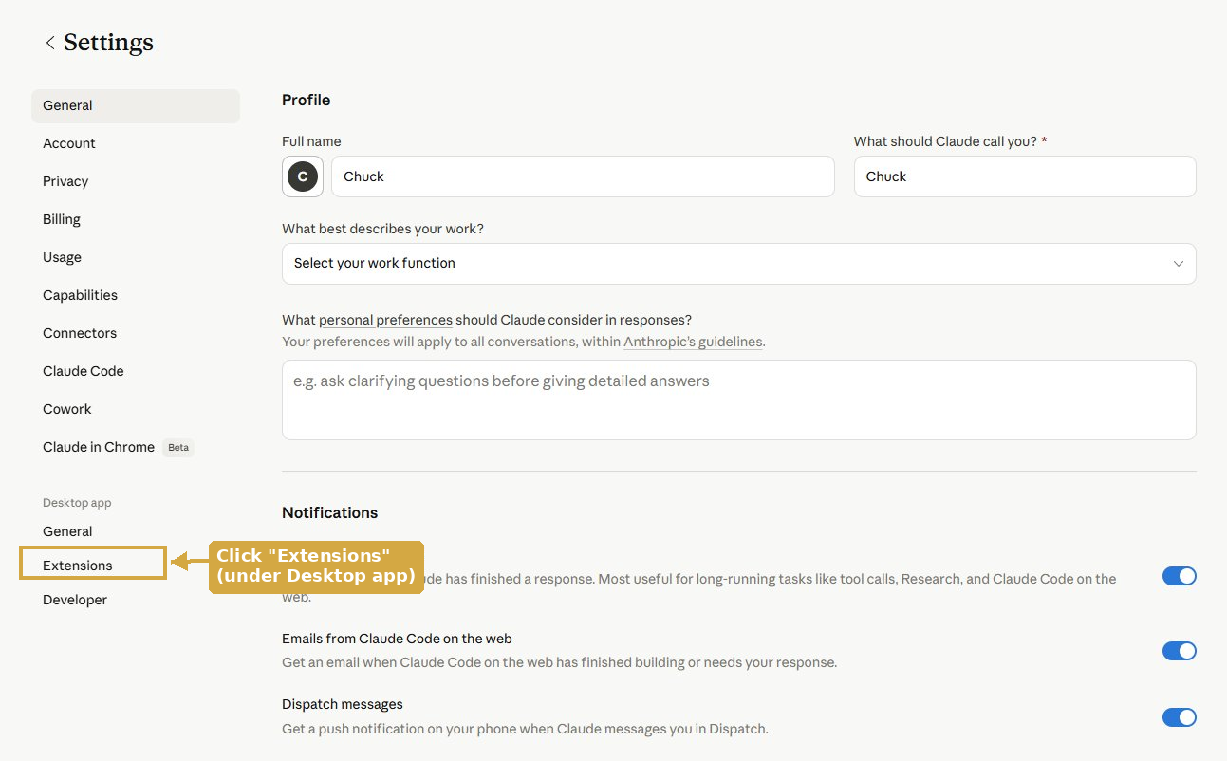
Click Extensions under the Desktop app section
- Click "Browse Extensions" in the upper-right corner
- Use the search bar at the top to find each extension by name. Click the "+" button next to each one to install it:
- Search "Filesystem" and click + to install. When asked, share your Documents and Desktop folders.
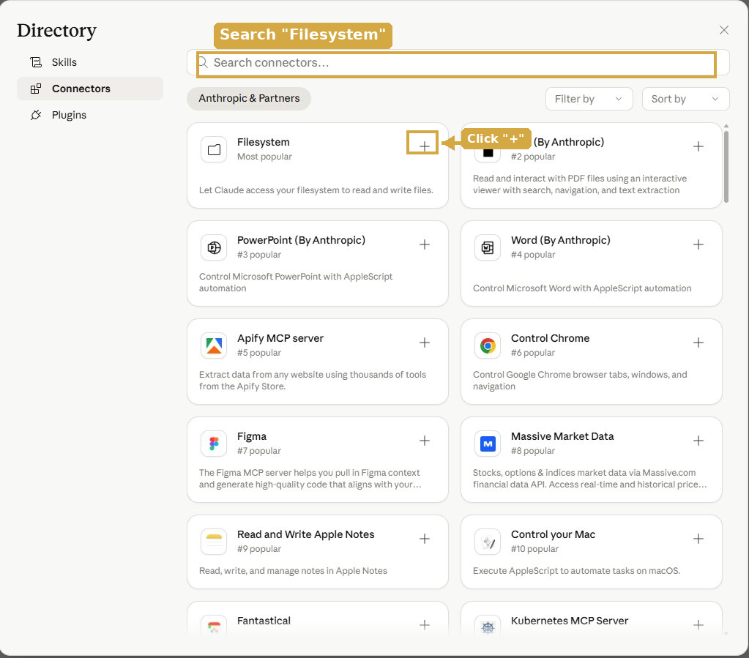
Search "Filesystem" and click + to install
- Search "Desktop Commander" and click + to install.
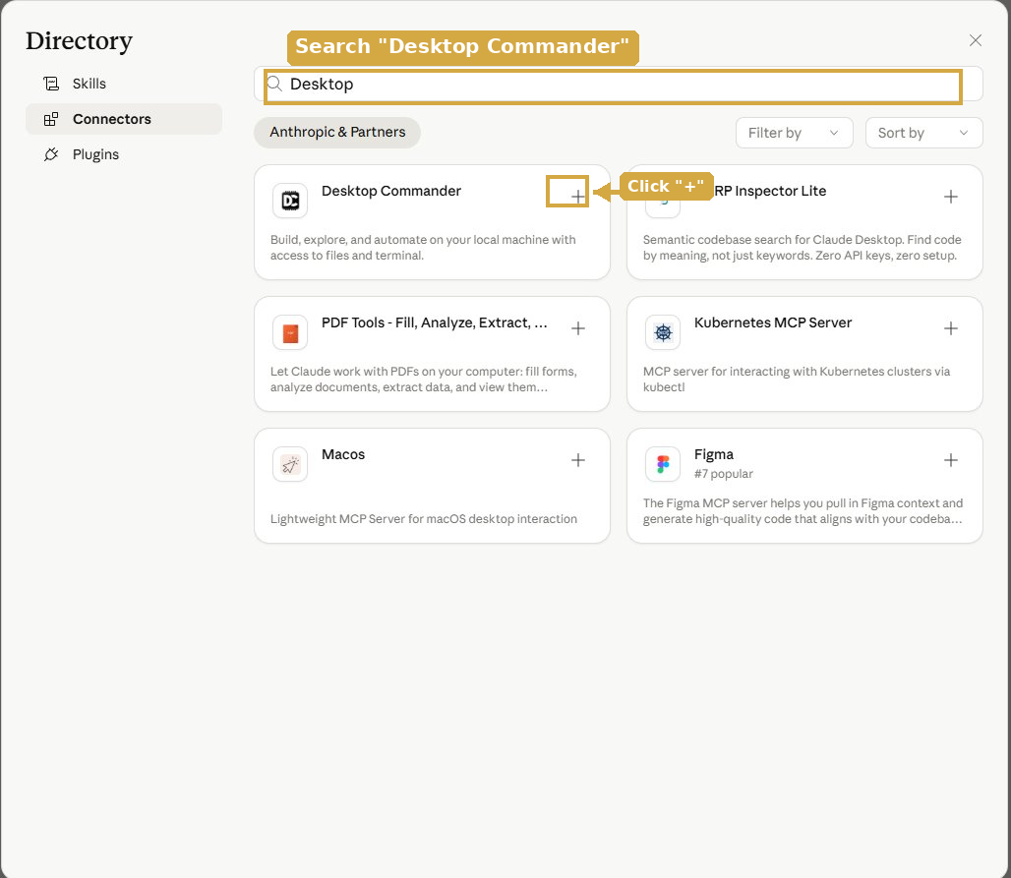
Search "Desktop Commander" and click + to install
- Search "Windows" and click + on Windows-MCP to install.
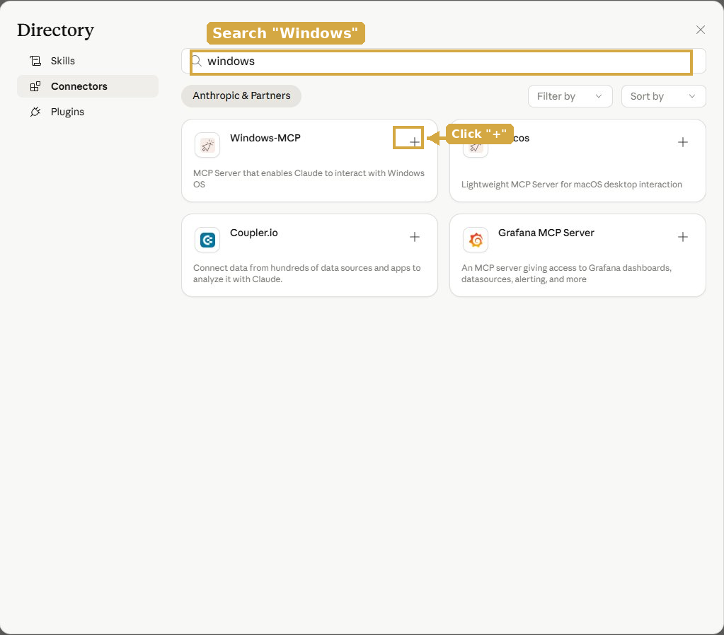
Search "Windows" and click + on Windows-MCP
- Close the directory and close Settings when done.

TIP: Claude Desktop bundles its own Node.js runtime, so extensions install cleanly with no extra software required.

Step 5: Install Claude for Chrome
This browser extension lets Claude navigate websites, click buttons, and fill forms on your behalf. When paired with Claude Desktop, you can research across multiple sites and have the results land in a formatted Word doc or Excel file without copying and pasting anything.
- Open Chrome and go to claude.com/chrome
- Click the install link and add the extension to Chrome
- Pin the Claude icon to your Chrome toolbar (click the puzzle-piece icon, then the pin next to Claude)
- Click the Claude icon in Chrome and sign in with the same account you used for Desktop
- Back in Claude Desktop, open any conversation and enable Claude for Chrome from the connectors menu so Desktop can drive the browser
IMPORTANT: Claude for Chrome is a beta feature. Start with trusted sites and familiar workflows. Avoid using it for banking, password management, or anything involving sensitive personal data. Claude will ask before taking irreversible actions like making a purchase, but you should supervise it closely until you trust how it behaves.

Step 6: Enable Computer Use
Computer Use lets Claude take screenshots and drive your keyboard and mouse to operate apps directly. This is a research preview available to Pro and Max subscribers on Windows and Mac. Turn it on now so it is ready when you reach Demo 7.
- Click your name or profile picture in the bottom-left corner of Claude Desktop
- Choose Settings from the menu, then click General under the Desktop app section on the left
- Scroll to the Browser Use section and toggle Computer use to ON
- Close Settings. You can add apps to the Denied apps list on this page later if you want to pre-block Claude from touching specific ones.
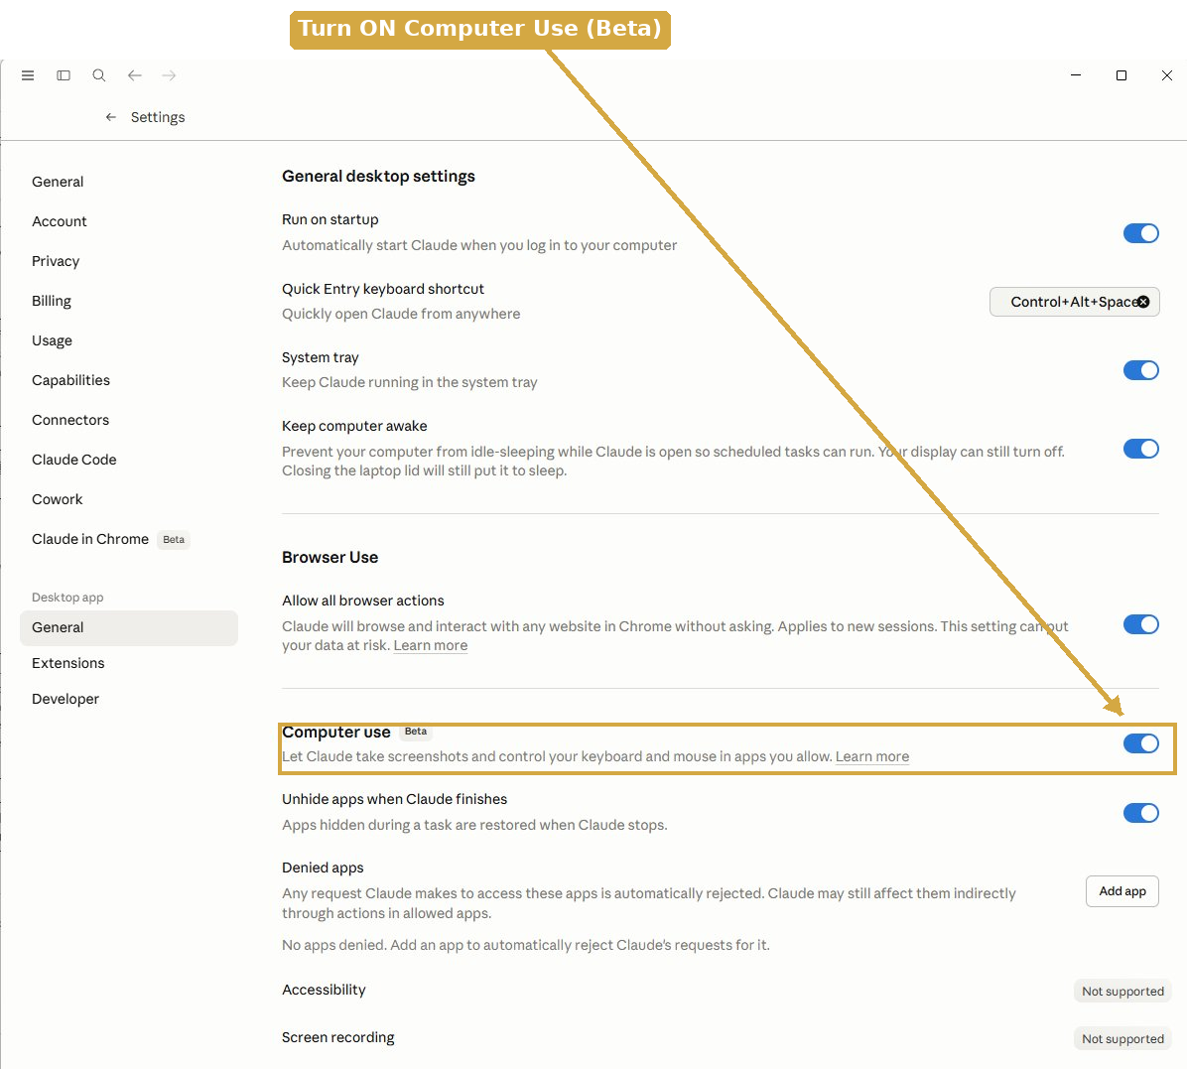
Turn on the Computer Use toggle
IMPORTANT: Computer Use is a Beta feature. Start with apps you trust. Do not use it with banking, password managers, or apps containing sensitive data. It may not always work perfectly, and Claude will ask before taking irreversible actions.

Step 7: Verify It Works
- Go back to Settings > Extensions (under "Desktop app" on the left)
- Under "Installed on your computer," confirm you see Desktop Commander, Filesystem, and Windows-MCP listed
- If you see all three, close Settings. You are ready for Part 2!
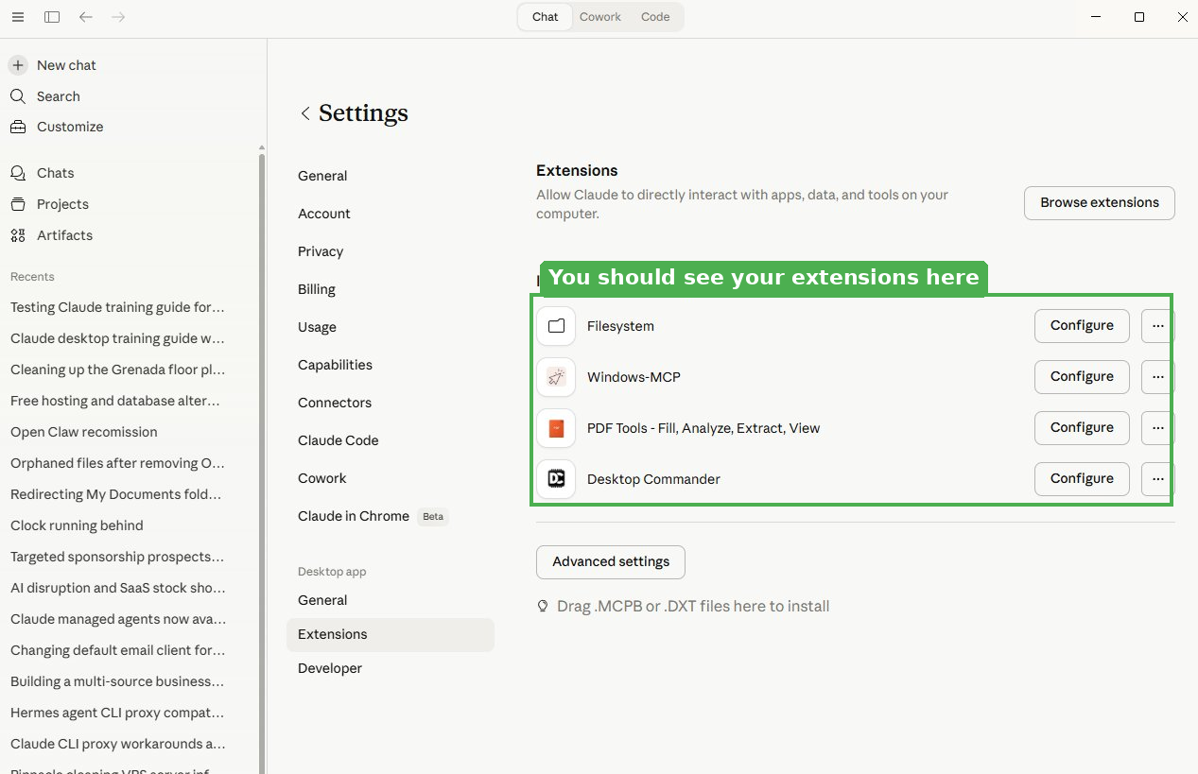
Success! Your extensions are installed and ready
Not seeing them? Try these fixes:
- Fully quit Claude Desktop (right-click the system tray icon near the clock > Quit) and relaunch
- Go back to Settings > Extensions and confirm they show as installed
- Check Settings > Developer for error logs if an extension failed to start

PART 2: LET CLAUDE DO THE REST
Paste One Prompt. Claude Verifies Everything.
Now that your extensions are installed, let Claude verify everything is working and show you what it can do. Paste the prompt below into a new chat.

IMPORTANT: Claude will ask your permission before each action -- running a command, reading a folder, creating a file. You will see a popup for each one. Review it and click "Allow." You stay in control at all times.

TIP: When pasting the prompt below, use Ctrl+Shift+V (Cmd+Shift+V on Mac) to paste as plain text. This avoids invisible formatting from Word that can sometimes cause issues.

COPY & PASTE THIS INTO CLAUDE:
I just installed Desktop Commander, Filesystem, and Windows-MCP
as MCP extensions in Claude Desktop. This is my first time using
MCP tools.

Please do the following:
1. Verify you have access to terminal commands and file
operations by listing your available tools.
2. Show me what is on my Desktop (list the files).
3. Check my disk space and RAM usage.
4. Create a text file on my Desktop called
'Claude Was Here.txt' with today's date and a short
greeting inside.
5. Confirm everything worked and tell me what else you
can do with these tools.

Claude will ask for your permission before each action (running a command, reading a folder, creating a file). Review each request and approve it. This is your first hands-on taste of what Claude Desktop with MCP can do.

PART 3: SEE WHAT CLAUDE CAN DO
Things No Other AI Chat Tool Can Do
These demos showcase capabilities that set Claude Desktop apart from browser-based AI chat tools. Because Claude can reach your files, Windows apps, and screen, it can deliver complete outputs rather than just answers. Try them in order.

IMPORTANT: For each demo, Claude will ask permission before running commands or accessing files on your computer. You will see a popup for each action. Click "Allow" to proceed, or "Deny" to skip.

Demo 1: Claude, Meet My Computer
Claude proves it can see and interact with your machine -- something no other AI chat tool can do.

COPY & PASTE THIS INTO CLAUDE:
Browse my Desktop and Documents folders and tell me what
you find. How many files are in each? What are the 5 most
recently modified files? What types of files do I have the
most of? Give me a quick snapshot of my digital workspace.

Demo 2: Scan and Brief Me
Claude finds a document on your computer and analyzes it without you having to upload anything.

COPY & PASTE THIS INTO CLAUDE:
Find the most recently modified Word document or PDF in
my Documents folder. Open it, read it, and give me a
3-sentence executive summary, the key takeaways, and any
action items or deadlines you can identify.

Demo 3: Open It For Me
Watch Claude interact directly with your Windows applications. No other AI tool can do this.

COPY & PASTE THIS INTO CLAUDE:
Open Notepad on my computer. Type a meeting agenda for
today with the title "Team Sync" and three placeholder
agenda items. Save the file to my Desktop as
"Meeting Agenda.txt".

Demo 4: Build a Shareable Tool
Claude builds a fully interactive business tool you can publish and share with your team. No login required for anyone who opens the link.

COPY & PASTE THIS INTO CLAUDE:
Build me an interactive ROI calculator for evaluating
software purchases. I should be able to input: software
cost per month, hours saved per week, and average hourly
labor rate. Show me the monthly savings, payback period,
and 3-year net ROI with a chart. Make it look professional
enough to share with my CFO.

TIP: After the tool appears in the panel on the right, click "Publish" to get a shareable link. Anyone you send it to can use the calculator in their browser -- no Claude account needed.

Demo 5: Live Research to Formatted Report
Claude searches the web, synthesizes findings, and delivers a polished document saved directly to your computer.

COPY & PASTE THIS INTO CLAUDE:
Research [COMPETITOR NAME] and create a one-page
competitive analysis. Include their strengths, weaknesses,
pricing, recent news, and how they compare to a company
like mine. Save it as a Word document on my Desktop called
"Competitive Analysis.docx" so I can open it directly.

TIP: Replace [COMPETITOR NAME] with a real company for the best results.

Demo 6: The Full Pipeline
Claude chains together every capability: creating data, analyzing it, building visuals, drafting communications, and delivering finished files. No manual steps required.

COPY & PASTE THIS INTO CLAUDE:
Create a realistic sample quarterly P&L spreadsheet and
save it to my Desktop. Then analyze it: calculate gross
and net margins, identify the largest expense category,
flag any red flags, and create a chart showing revenue vs
expenses by month. Finally, draft a 1-paragraph executive
summary I could send to my board.

Demo 7: Operate an App for Me
With Computer Use enabled in Step 6, Claude takes screenshots and drives your keyboard and mouse to operate apps directly.

COPY & PASTE THIS INTO CLAUDE:
Open the Windows Calculator and compute the monthly
payment on a $350,000 loan at 6.5% APR over 30 years.
Walk me through what you are doing, and tell me the
answer when you have it.

Demo 8: Research Without Switching Tabs
With Claude for Chrome enabled, Claude navigates real websites, pulls information, and hands the results back to Desktop to deliver a finished document. You stay in Claude Desktop the whole time.

COPY & PASTE THIS INTO CLAUDE:
Use Claude for Chrome to research three competitors in
my industry. Visit each one's homepage and pricing page.
Pull their positioning, key features, and pricing. Then
build a one-page comparison document and save it to my
Desktop as "Competitors.docx" with a table showing
each side by side, and a short takeaway paragraph.

TIP: Replace "my industry" with a specific one (for example, "commercial cleaning in South Florida") for sharper results. Claude will ask you to approve each site visit before it navigates. Stay in Claude Desktop; it drives Chrome from there.

Power Features to Explore Next

Projects
Persistent workspaces with custom instructions and uploaded documents. Click "+" next to "Projects" in the sidebar.
Custom Styles
Save writing presets. Your name (bottom-left) > Settings > Styles. Or tell Claude "write like this from now on."
Memory
Claude remembers your preferences and working style across conversations. Managed in Settings.

Quick Reference Cheat Sheet

I Want To... | Do This...
Start a new chat | Click "New Chat" in the top-left sidebar
Upload a file | Click "+" at bottom of input bar, then "Add files or photos"
Switch models | Click the model name below the input bar
Create a project | Click "+" next to "Projects" in sidebar
Check installed extensions | Your name (bottom-left) > Settings > Extensions
Install new extensions | Settings > Extensions > Browse Extensions
Check error logs | Your name > Settings > Developer > view logs
Use voice mode | Click the microphone icon in the input bar
Search the web | Just ask. Claude searches automatically.
Create a document | Ask Claude to "create a Word doc" or "make a presentation"
Share an artifact | Click "Publish" on any artifact for a shareable link

Troubleshooting

Problem | Solution
Extensions not showing up | Fully quit Claude Desktop (right-click system tray > Quit) and relaunch. Check Settings > Extensions.
Server keeps disconnecting | Check Settings > Developer for error logs. Try uninstalling and reinstalling the extension.
Windows-MCP won't install | Python must be installed with "Add to PATH" checked and your computer rebooted. Reinstall Python with that option, reboot, then try again.
Claude cannot find files | The Filesystem extension only sees directories you gave it access to during setup. Reinstall or reconfigure it.
Permission denied errors | Some folders require admin access. Try pointing the Filesystem extension to your Documents or Desktop instead.
Clicked Allow but nothing happened | Fully quit Claude Desktop and relaunch. If it persists, check Settings > Developer for error logs.
Claude says it lacks access to a tool | Go to Settings > Extensions and confirm it is listed under "Installed on your computer." If not, install it. If it is, fully quit and relaunch.

Still stuck?
Paste this entire document into a new Claude Desktop chat with the message: "I am having trouble with setup. Help me troubleshoot." Claude and Desktop Commander can often diagnose and fix problems directly.

Need Help Getting Started?

Your Future Won't Wait.
Chuck Poole, Principal Consultant
561-373-2547
chuck@whiterabbitadvisorygroup.com
whiterabbitadvisorygroup.com

